The purpose of this document is to outline the processes that the Change of Major Workflow follows to be used in training Academic Department Chairs, and Secretaries.

The Change of Major processes begin with the front-end client web page that students can access via the myESU portal. The student is presented with 8 options which are:
- Add a Major
- Change a Major
- Add Minor
- Change Minor
- Add Concentration
- Change Concentration
- Drop Major
- Drop Minor
- Drop Concentration

Once the student chooses one of the options, he is presented with a screen that collects what Major, Minor, or Concentration he wants to add, change, or drop. Logic is included to ensure that the student does not drop his only Major or drop his only Concentration in a Major that requires a Concentration. Once the student has made all required choices, the information he has input is sent to the Change of Major Workflow where his request “flows” to the proper Academic Departments for approval.

The Change of Major Workflow collects the following information:
- Student’s Option Add, Change Major, Minor, …etc.
- Student’s ID Number
- New & Current College Code Required for a New Major
- New & Current Concentration Required for New Concentration and some Majors
- New & Current Degree Required for New Major
- New & Current Dept. Code Required to determine which Dept. Chair to contact
- New & Current Major / Minor Used for New Majors and New Minors
- New & Current Program Code Required for New Major
- Student Comments Optional from Student

Access to Workflow
Generally, Department Chairs, Secretaries, and Enrollment Services staff will access Workflow through a link included in an email sent to them. This link will bring them to a specific Workitem on their own Worklist. This is the preferred method of access to Workflow since it specifies the request being addressed. Multiple requests may be (and likely will be) found in a user’s Work List. Enrollment Services also has the added responsibility of monitoring and maintaining active Change of Major Workflows. Any authorized user can access Workflow and view any Work Items in their own Worklist by following the Workflow URL: http\\www.esu.edu\workflow . This URL brings up the Workflow logon page (see Figure 1).

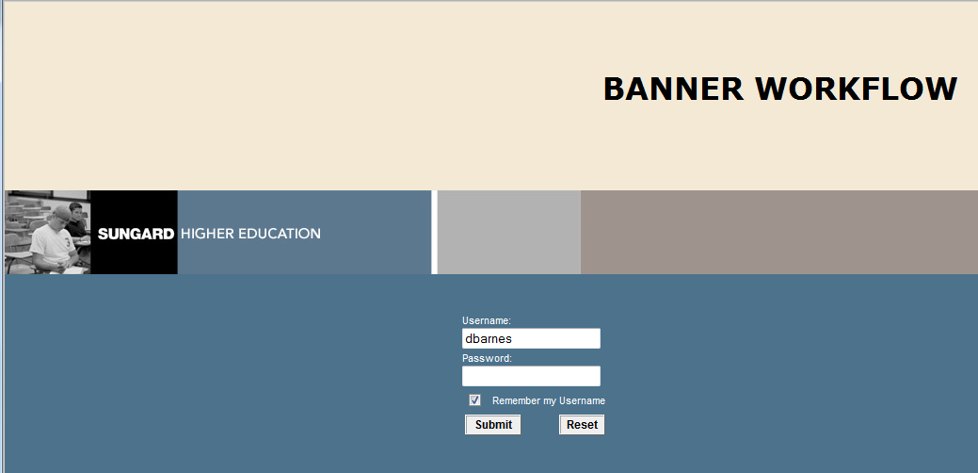
Figure 1 – Workflow Logon Page

The user’s username and password are the same as their Banner INB username and password. Once the user logs on, they are presented with their Workflow Home Page which, by default, shows their current Worklist (see Figure 2).

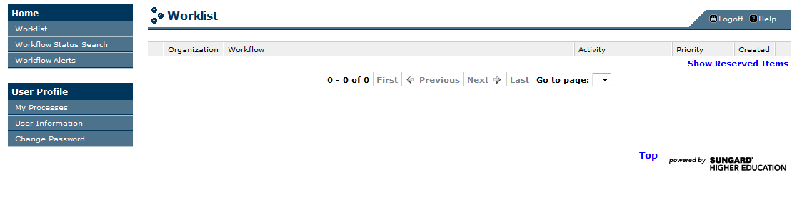
Figure 2 – Home Page with No Open Work Items in Worklist

The number of options on the left side of the window changes depending on the role the user has been assigned. Figure 2 (above) shows the Home Page of a Department Chair. It is IMPERATIVE to note that no user should attempt to use the “Change Password” option as a user’s username and password are synchronized to the their Banner INB username and password.

The first part of the Change of Major Workflow contains a number of automatic activities. Automatic activities access Banner tables to get the current and proposed student’s data for presentation and approval. Since these activities are automatic, they require no user intervention.
Figure 3 – Workflow Automatic Activities

Figure 4 – Workflow Alert Message

The first decision point in the workflow checks the Option to determine if the Workflow needs to use the student’s Major Department or a new Minor department.
If the student’s request involves a new department, the new Department Chair is checked to ensure he has a valid Banner and Workflow username and password.

ENROLLMENT SERVICES: If there is no valid Banner username, an email is sent to notify the student that the request they have submitted has been received and they will be notified within 2 business days as to its status (see Email 1).

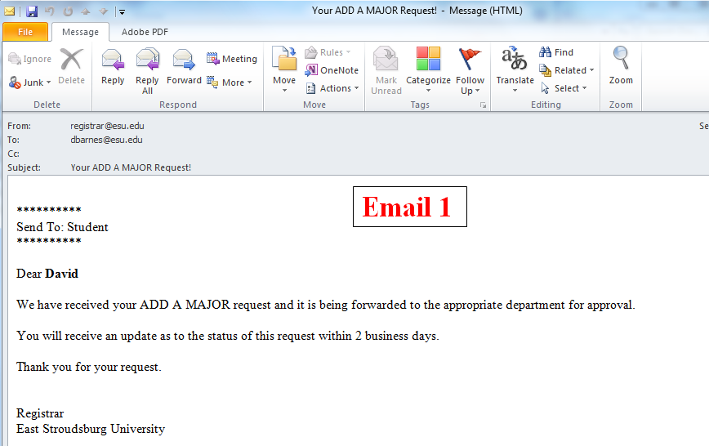
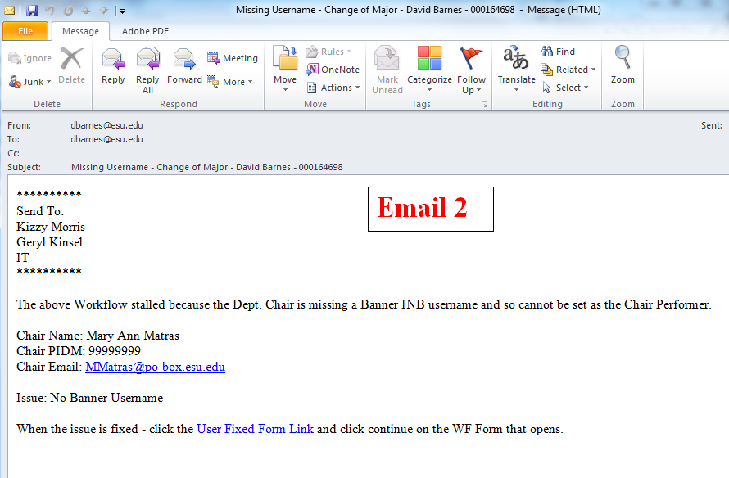
This 2 days is the timeframe to get the chairperson a valid Banner username. At this point an email is sent to Enrollment Services with the Subject of “Missing Username – Change of Major – ‘Student Name – Student ID’”. It also includes the chairperson’s name, PIDM, email address and the Issue which says, “No Banner Username,” (see Email 2).

Enrollment Services must fix the issue so the chairperson has a valid Banner username. This email also contains a link named “User Fixed Form Link,” which is to be used by Enrollment Services staff once the chairperson has a valid Banner INB username.
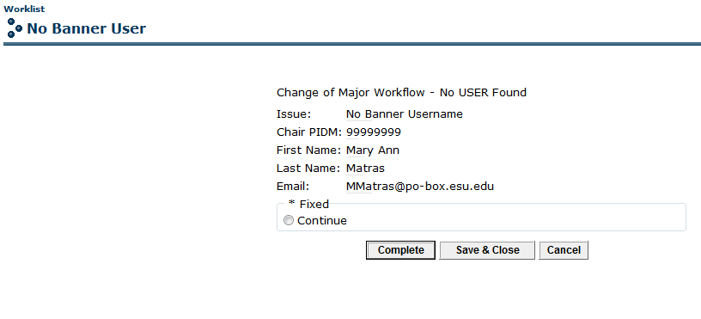
Figure 3 – No Banner User Form

Once the appropriate department chairperson has been identified, the first “official” email notification is sent out (see Email 3).
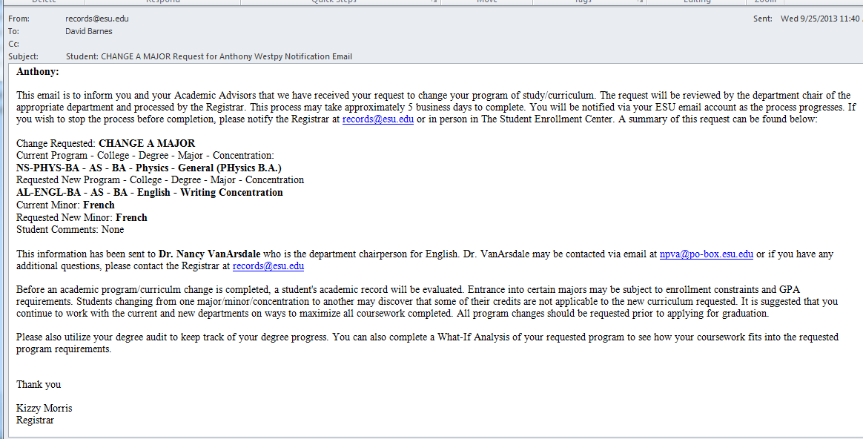
Email 3
This email is sent to the student, his current advisor(s), the department chair that is to approve the request, and Enrollment Services staff. All the appropriate information about the change is included in the email and the student is instructed that if they have any questions – i.e., they don’t want to pursue the change – they can contact the Registrar via email. Immediately after the notification email is sent, another email is sent to the approving department chairperson (see Email 4) stating the request and including a link to be used to approve or deny the request.

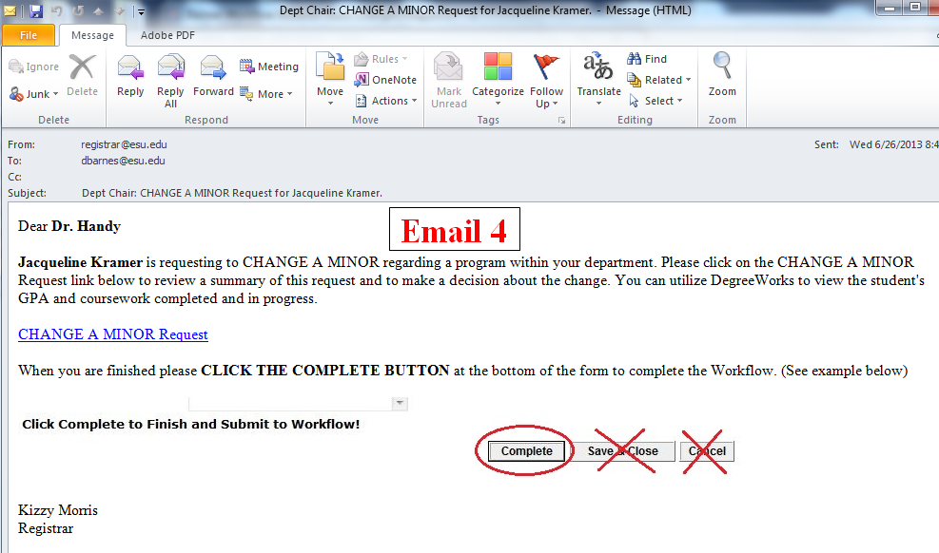

Department Chairperson: The email requesting your approval for a student’s change includes a link with the same name as the type of change the student is requesting. Notice in the example email (Email 4) that the subject line identifies the type of change as “CHANGE A MINOR” and the link is CHANGE A MINOR Request. At this point, you (the department chairperson) click on the link which will bring you to Workflow. If you are already logged into Workflow you will be automatically directed to the Change Request Form. If you are not logged into Workflow, you will be presented with the Workflow logon screen where you will need to enter your username and password. As previously mentioned, your Workflow username and password is the same as your Banner INB username and password. Once you have successfully logged on, you will be presented with the Change Program of Study Approval Form. Figure 4 is an Add a Major form, please note the separate page with the other Approval request forms as well.
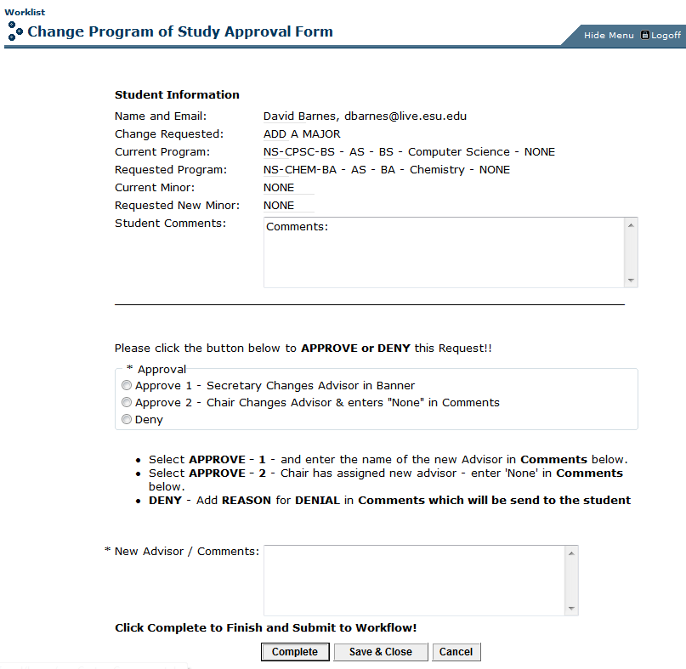

The Approval Form changes slightly based on the type of change being requested. If a student, for example, wants to change a Concentration there is no need to change his advisor so the form to change a Concentration does not include any options to add or change an advisor. If the department chairperson wants to contact the student, the student’s name on the form is actually an email link. By clicking the student’s name, a new email message from Outlook will open with the student’s email address in the “To” field and the “Subject Line” filled out with “Regarding your Program of Study changes.” The chairperson can add any text and send the student an email. If the chairperson then needs to wait on a response from the student, he can merely close Workflow and click the email link to get back to the form when he is ready to proceed.

The form is relatively self-explanatory – the student’s information is included on the form along with the changes proposed by the student. There are 3 radio buttons that correspond to the 3 options the chairperson has – Approve 1, Approve 2, or Deny. The chairperson clicks the radio button that corresponds to his choice, then enters required information in the New Advisor / Comments box, and finally clicks the Complete Button to finish the approval. Here is an explanation of the 3 options:
- Approve 1 – The department chairperson chooses this to approve the change and send the process to his department secretary who is to update the student’s advisor in Banner. In this scenario, the department chairperson enters the name of the new advisor in the “New Advisor / Comments” box and clicks the Complete Button.
- Approve 2 – The department chairperson chooses this to approve the change and bypass the secretary because he has already updated the student’s advisor information in Banner. In this scenario, the department chairperson enters “None” in the “New Advisor / Comments” box and clicks the Complete Button.
- Deny – The department chairperson chooses this to deny the change request and send a notification email to the student of the denial. In this scenario, the department chairperson enters his reason for denial in the “New Advisor / Comments” box and clicks the Complete Button to finish the request. In the case of a denial, whatever the chairperson enters into the “New Advisor / Comments” box is sent to the student as the reason for the denial.

This completes the department chairperson’s role in the Change of Major Workflow process with one possible exception. Once the process gets to the Registrar to actually make the changes, the Enrollment Services staff may need some clarification from the chairperson. In that event, an email will be sent to the chairperson requesting the information required to complete the request.

Department Secretary: When the department chairperson approves a change to a student’s program of study, it is possible that the student’s advisor may need to be changed or another advisor would need to be added. In the approval process the department chairperson may approve the request and assign the advisor himself or he may approve the request without updating the student’s advisor information. In the latter case, he will choose the new advisor and an email will be sent to the department secretary (see Email 5 below) requesting the secretary to update the student’s advisor information in Banner. Department secretaries have a Workflow username and password that is the same as their Banner INB username and password. The email sent to the secretary includes the Student Name, Student ID, Advisor Name, and the type of change that needs to be made. Toward the bottom of the email is a Edit Student Advisor Link. The secretary should click the link to complete the process. If the secretary is not logged into Workflow the link brings up the Workflow logon page (see Figure 1 above). The secretary logs in using their current Banner INB username and password. Once logged in, Workflow will open Banner INB and go directly to the SGAADVR form and insert the Student’s ID and name.
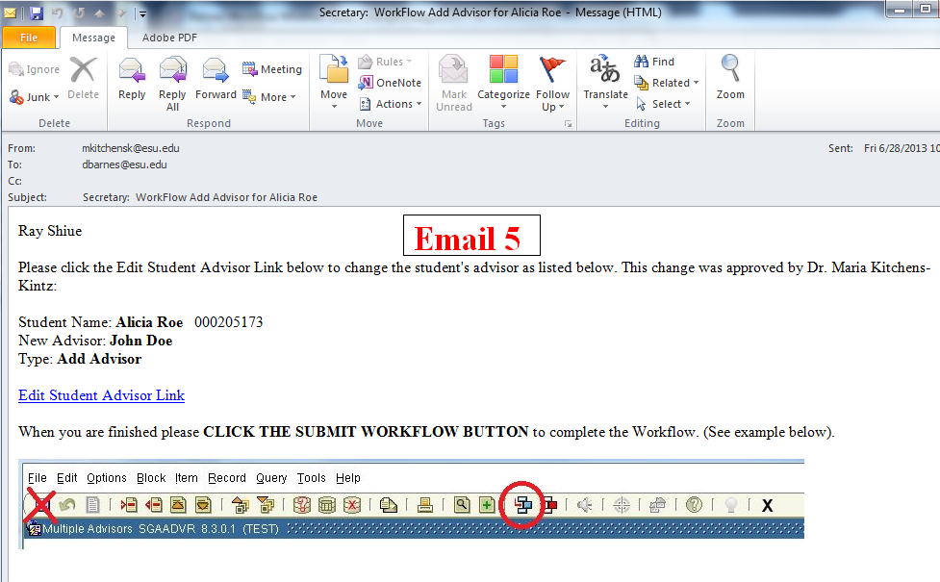

The secretary then makes the changes to the student’s advisor information as normal BUT IT IS IMPERATIVE that rather than using the Save icon to save the changes, the secretary must use the Workflow Submit icon which will save the changes and notify Workflow automatically that the changes have been made (see Figure 5 below).

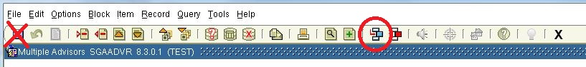
Figure 5 – Submit Workflow Icon is circled in Red

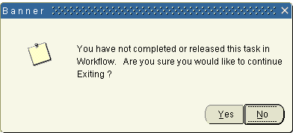
If the Workflow Submit icon is not used, the Workflow will wait for confirmation that this task has been completed. If the secretary forgets to use the Workflow Submit icon to finish the change and attempts to close the form, Banner will issue an error message “You have not completed or released this task in Workflow. Are you sure you would like to continue Exiting?” (see Figure 6). At this point, if the student’s advisor information has been updated, the secretary should click the “No” Button and then click the Workflow Submit Button to finish this activity. A secretary who does leave the page without using the Workflow Submit Button after updating the advisor information should go back the email (see Email 5), click the link again and merely click the Workflow Submit Button once Banner INB opens up SGAADVR again to finish the task.
Figure 6 – Workflow Submit Error in Banner

Registrar / Enrollment Services: The request will come to the Student Enrollment Center to be processed.

