Each faculty member has their own comfort level with D2L and using its tools. These steps listed below cover the very basics of the system. How to access ESU’s D2L environment, how to upload course material and how to create basic assessments. Remember communication is key to a successful online course. Be direct and clear with your students and provide feedback as quickly and clearly as possible.

- Log into ESU’s D2L environment using your normal credentials.
- Navigate to the desired course shell. The image below shows both locations of courses you would be enrolled in as a faculty member.
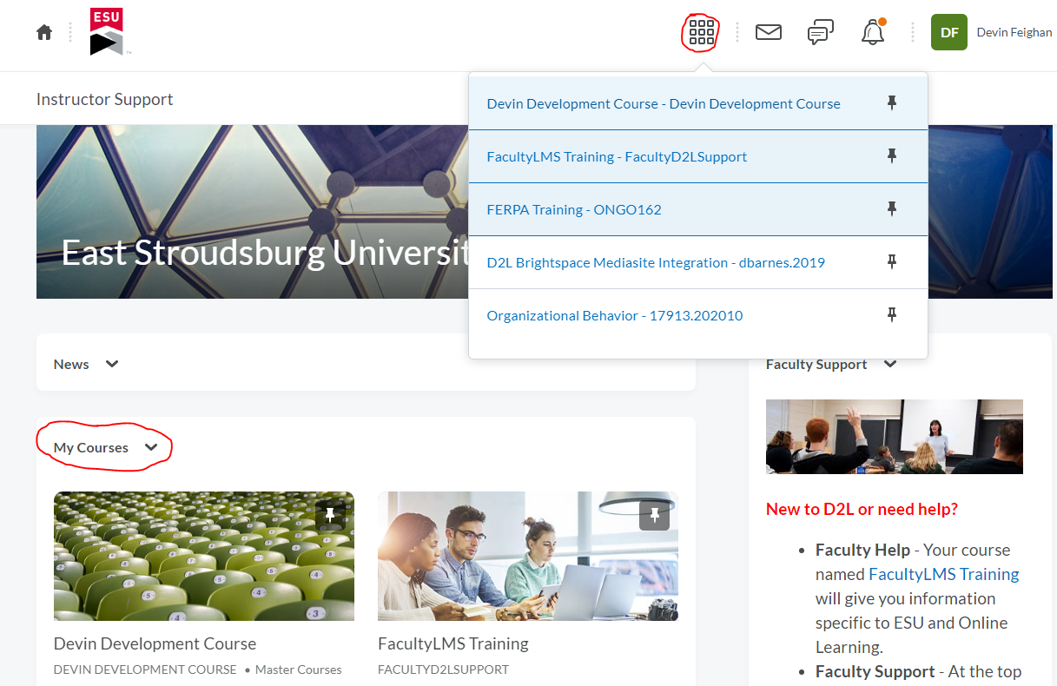
- From inside the course shell, navigate to the content area in the navigation bar and begin adding course materials. Organize content into Modules for better organization and to avoid confusion with your students.
  - Creating Modules in D2L - Think of modules as a folder for your course materials that students will need for that week, chapter, or unit that you deliver.
  - Uploading Content into D2l - D2L can upload a variety of material formats into topics. Anything such as PDF readings, PowerPoint presentations, Videos (both created and from outsides sources), Word documents, etc.
  - Already have an older course shell with material? Copy that material over into a new shell from an old one.
- Think about your assessments.
  - Will your students be creating something to submit to you? Use the Dropbox tool
  - Are there quizzes that need to be delivered? Create your exams or quizzes in the D2L tool.
- How will you interact with your students?
  - ESU email
  - Want to create discussion boards in D2L? Create discussion boards for students to post graded assignments and general questions.
- Managing grades in D2L.
  - Setting up your gradebook for the first time? Create your grading scheme for the first time.
  - Not sure how to organize your gradebook?
    - Create Categories
    - Create Grade Items
  - Not sure how to attach an activity with a grade time? Associate activities through these steps.
- When ready to deliver the course, remember to activate the course shell.
- Facilitating the course.
  - Use announcements to quickly update students on new material or general info
  - Locate the Class Progress tool under the Assessments dropdown menu - D2L’s class progress tool can keep you up to date on user activity in the course.

Transitioning to an online delivered course can be challenging. Keep in contact with your students, use the D2L tools to help you identify who has been keeping up with content and assignments and who has not. Keep things simple in the course and remember that we are here to help.

For more information please email Devin Feighan dfeighan@esu.edu at the Center for Teaching with Technology.

