**“My SECA Story”**

**United Way Success Story – Promoting Self-Sufficiency and Meeting Basic Needs**

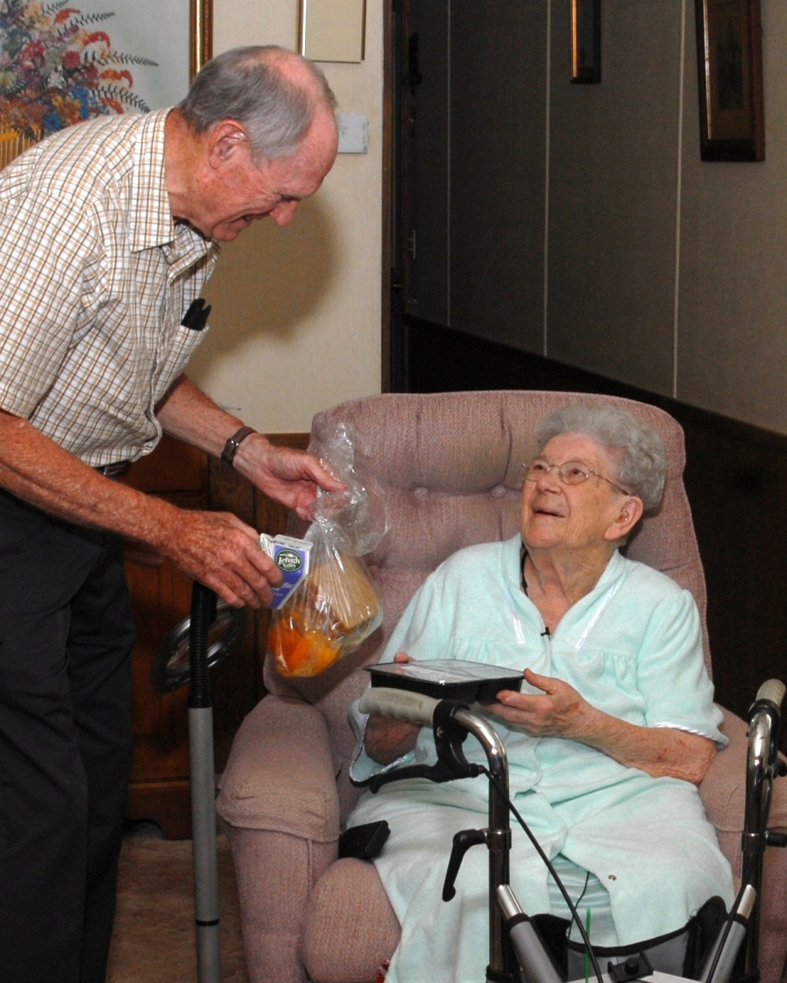

Ninety-year-old Edith Flory of Marshalls Creek wants to be able to stay in her own home and lead her life as independently as possible. She enjoys the company of her Siamese cat and the bucolic view outside her trailer. She has plenty of room for her large collection of Hummel figurines – which she would not have in an assisted living facility or nursing home.

For these reasons and more, Edith is a client of Meals on Wheels, a program that is funded by United Way of Monroe County.

Edith receives home-delivered meals (hot and cold) through the program five days a week. She became a client after she had been in the hospital and someone suggested she use Meals on Wheels. She tried it and decided she liked the service. That was three years ago!

She enjoys the food and it gives her the balanced nutrition she needs. The visit from her Meals on Wheels volunteer is also one of the highlights of her day. She keeps busy by knitting and spending time with her family, including her grandchildren and great grandchildren. She even volunteers by helping with the tickets for the annual Meals on Wheels Wing-off fundraiser...right in her favorite chair.

In the comfort of her own home and familiar surroundings, Edith tries to be as independent as is possible for an almost 91-year-old. Meals on Wheels and United Way help her do just that.

**United Way Success Story – Meeting Basic Needs**

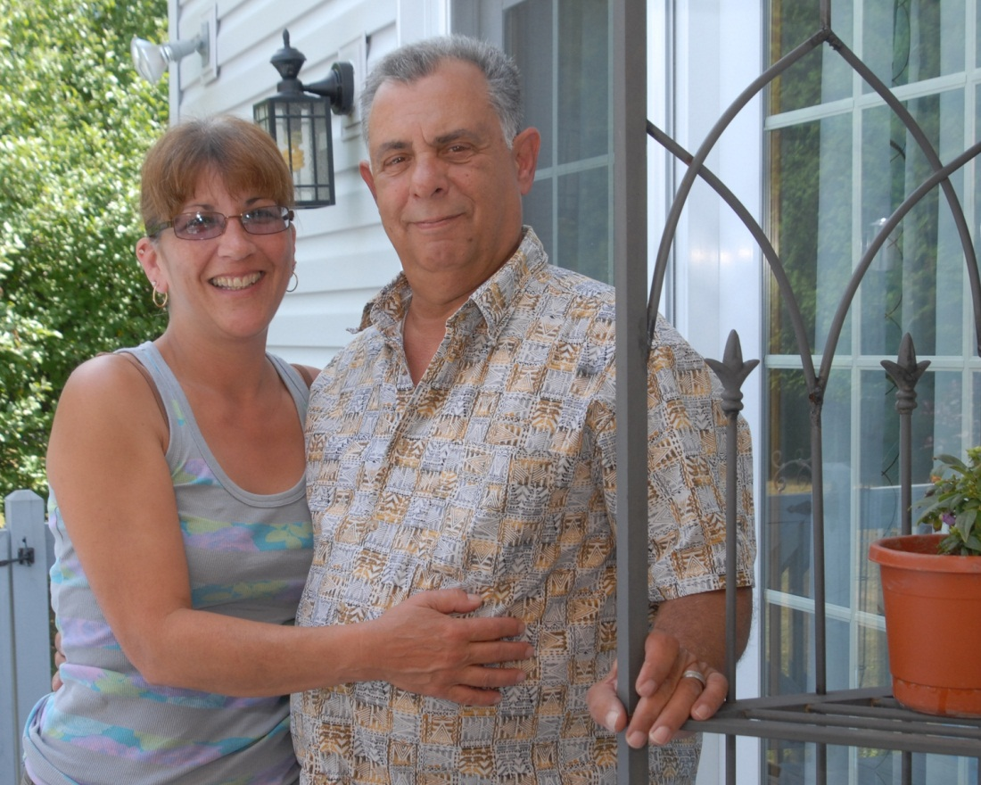

On April 23, 2010, Sam and Deb Vallese had just settled into their “parent cave” in the lower level of the McMichaels home they shared with two of their five children and a granddaughter. Sam heard what he believed was the microwave or oven beeping, and thought he smelled something burning. He got up and walked to the garage door, only to open the door to find a wall of flames and smoke. The beeping sound had come from the home’s smoke detectors, but was not a familiar sound that registered with him.

The family quickly dove into “panic mode.” Debbie recalled, “We were in our pajamas and headed for the door.” She and Sam gathered the family and steered everyone to safety. When firefighters arrived on the scene, the home was engulfed, but the Vallese family was unhurt.

Rescue personnel immediately contacted the American Red Cross in Monroe County, a United Way partner agency. The local chapter works to provide services to disaster victims, and from the cell phone of one emergency responder, asked to speak to the family immediately. Deb spoke to an agency representative as the home continued to burn, and a few hours later, the family was directed to a local hotel to rest – American Red Cross took care of all the arrangements for them. While sleep did not actually come that night, Sam and his family were further surprised as they received a debit card for immediate necessities and a comfort kit, containing toiletries and essentials. It was these small acts of kindness that helped the family begin the recovery process from such an unexpected, life-changing disaster.

“It was such a relief to us,” noted Sam, “as I lost my wallet, cash, cards, everything in that blaze.” What does one do at 4:00 a.m. with nothing but your family by your side? For Sam and Debbie, they realized that without the help from the American Red Cross and United Way funding, the ordeal would have been much worse.

“I was lucky, in a sense, that we had good insurance coverage,” shared Sam. “In the end, our home was completely rebuilt by local contractors in just two months. It was incredible.”

United Way Success Story – Helping Children Succeed

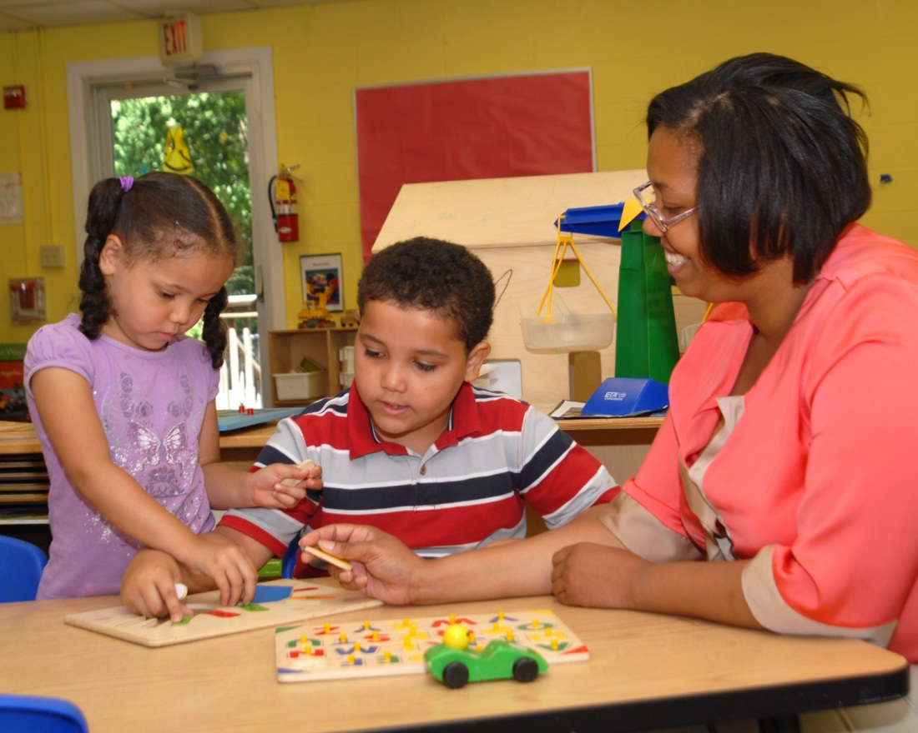

Like the pieces of a puzzle, Carmen’s life has come together with support from three United Way-funded programs. When she was homeless, she was assisted by The Salvation Army and PATH. Besides shelter, she received counseling and learned to set/meet goals. Now, she and her kids receive comprehensive services from Head Start, a high-quality preschool program for low-income families run by Pocono Services for Families and Children. Michael, who has special needs, is getting ready for success in kindergarten, while Anna has another year of preschool. The family has been assisted with transportation and provided with comprehensive educational, health, and social services. Carmen has attended workshops on budgeting and nutrition. A single-mom, she is enrolled at Northampton Community College to earn a degree in diagnostic sonography. She has high hopes for her family’s future.