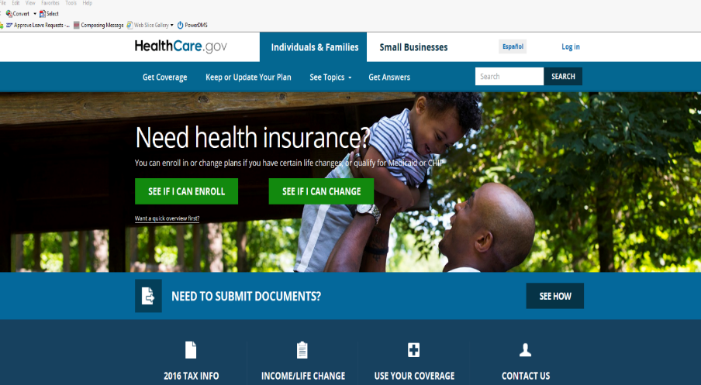**For assistance in finding Health Insurance Go to “Healthcare.gov”**

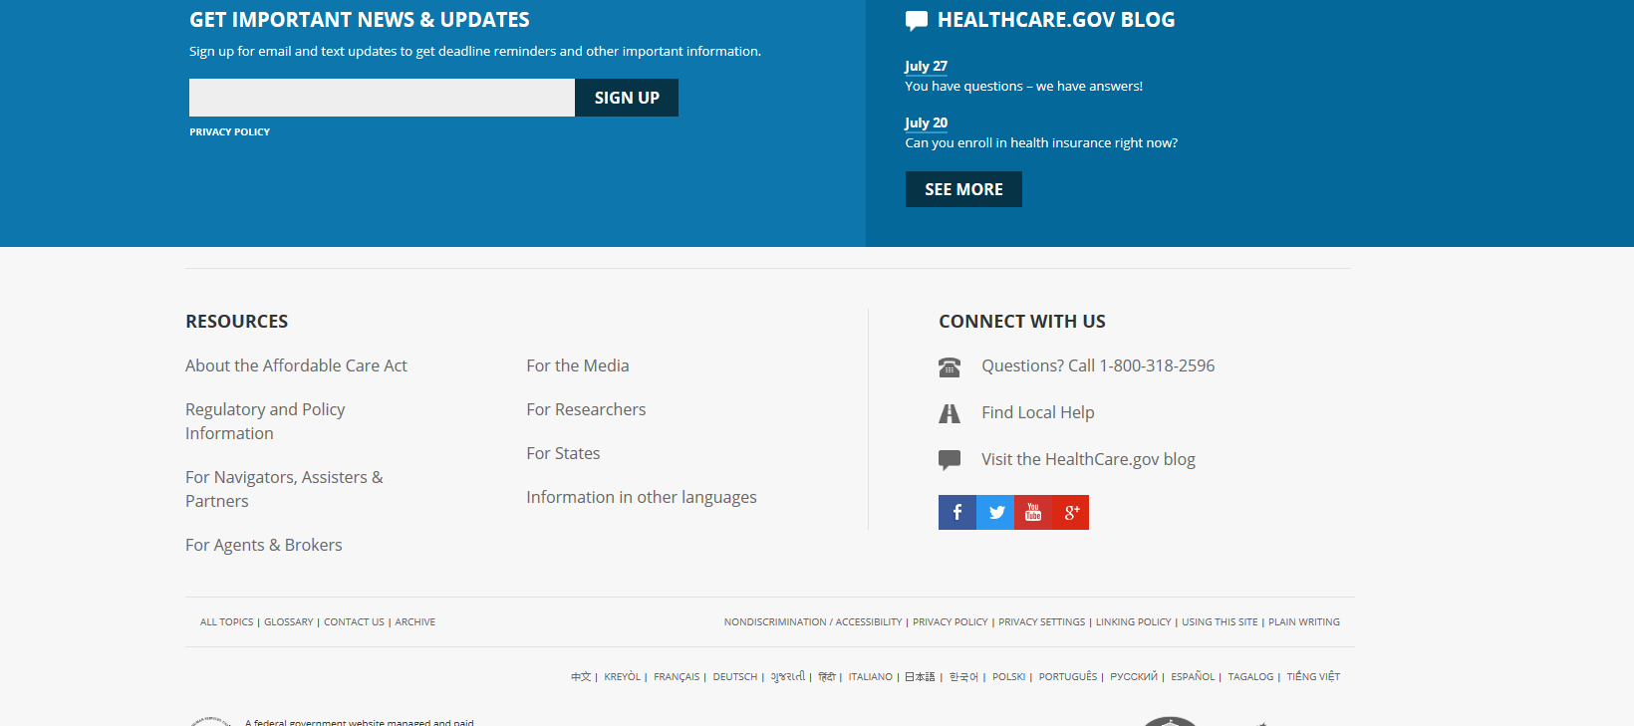**Scroll to bottom of page and click “Find Local Help”, enter local zip, choose “Coverage for myself”**

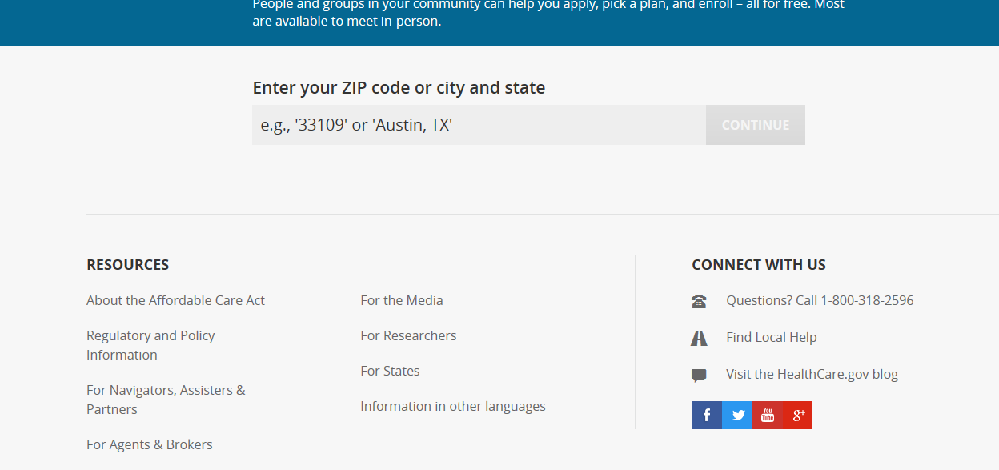

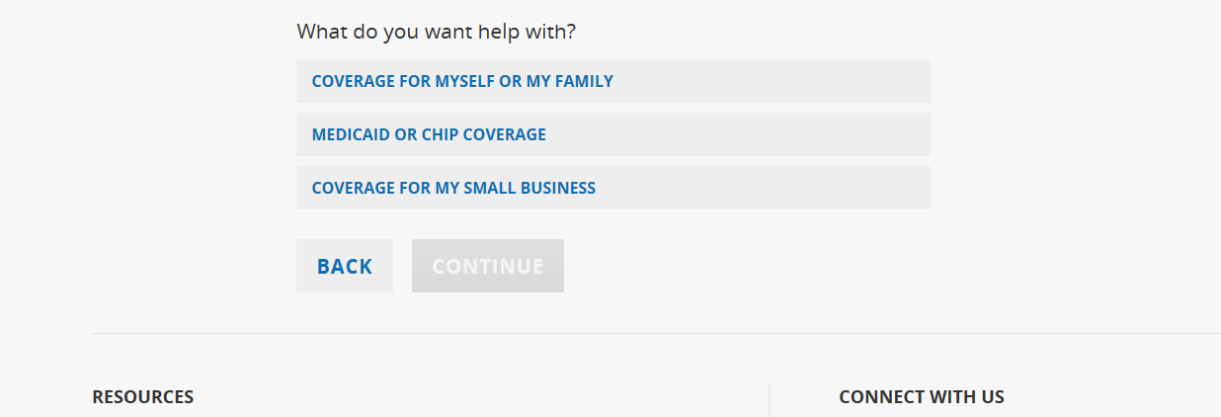

**Choose “No List Results”**

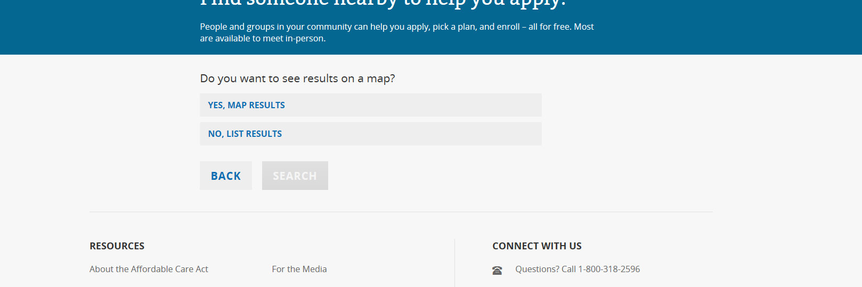

**List of local “Assisters” to help with finding appropriate Health Insurance in local area**

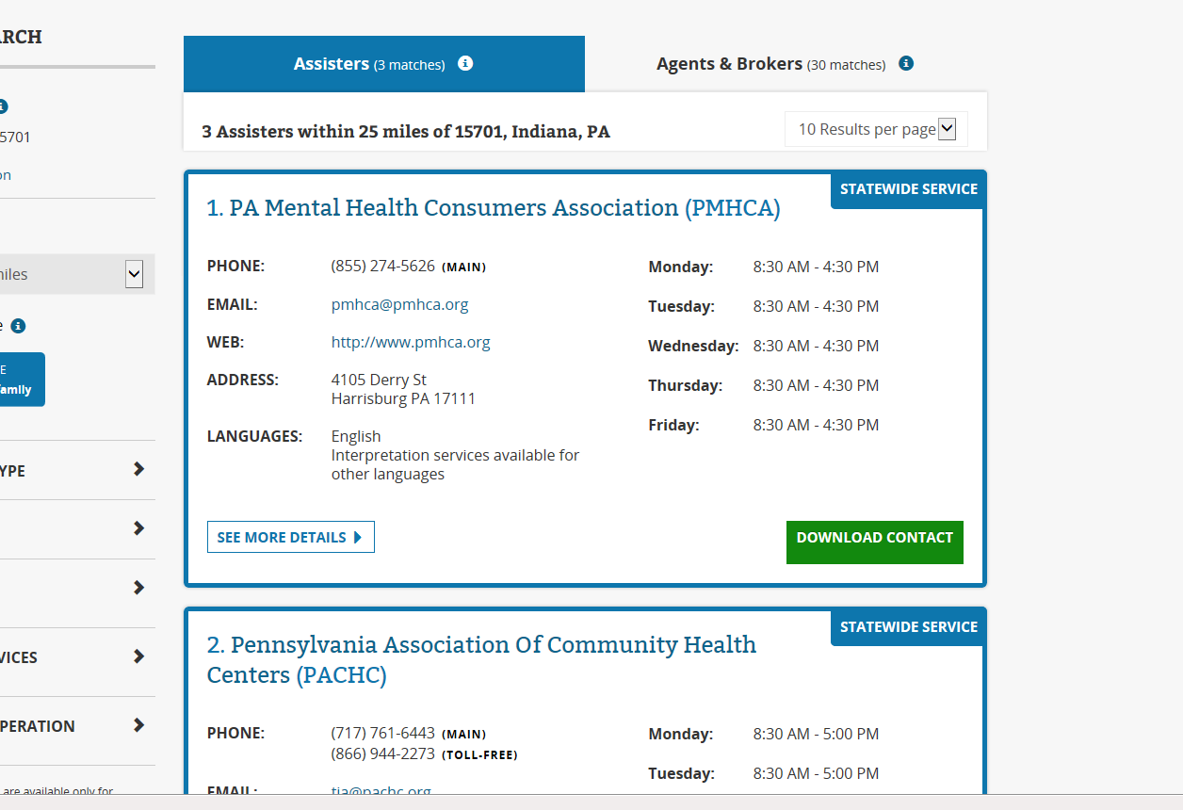

**Or simply call 1-800-318-2596**

