Adding Student Addresses to Admin E-Mail List

To setup access to the Student e-Mail address list in Outlook

Open Outlook:
In the "Tools" drop down menu, select "E-Mail Accounts"
Under "Directory", select "Add a new directory or address book" and then click on the Next > button

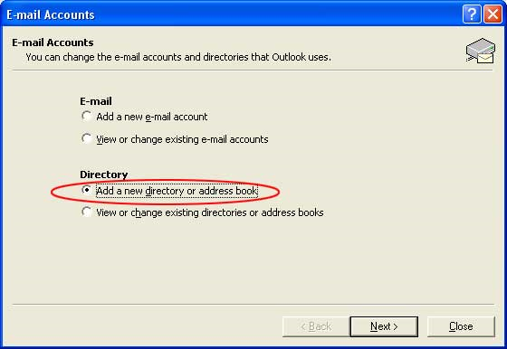

In the "Server Name" field, type in: student-list
Check the box for "Logon Information" and enter admin\username using your own username.
In the password field, enter your e-mail password.
Click on the "More Settings..." button

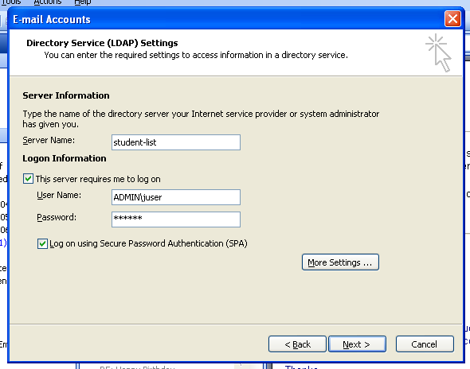

After you click on more settings, change the tab in the new window to Search. In the Search base field, type in:

cn=users,dc=esu,dc=edu

And then click on the "OK" button.

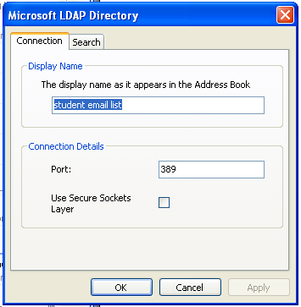

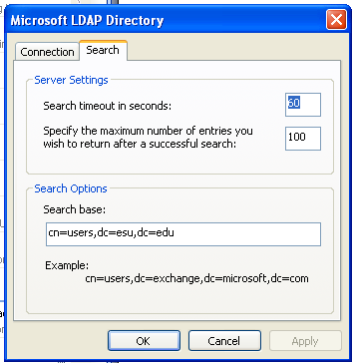

This will take you back to the previous window for E-Mail Accounts.

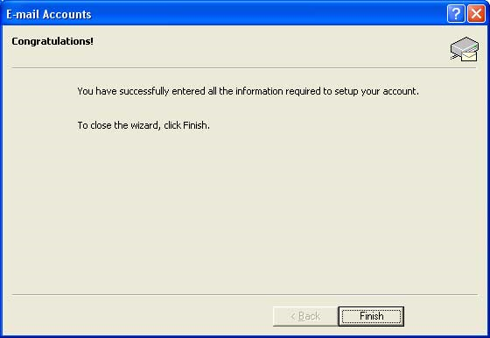
After you complete these steps, you will be able to access the students e-mail addresses from your address book in Outlook. The list will be called student-list unless you changed it to something else, like "student addresses".

