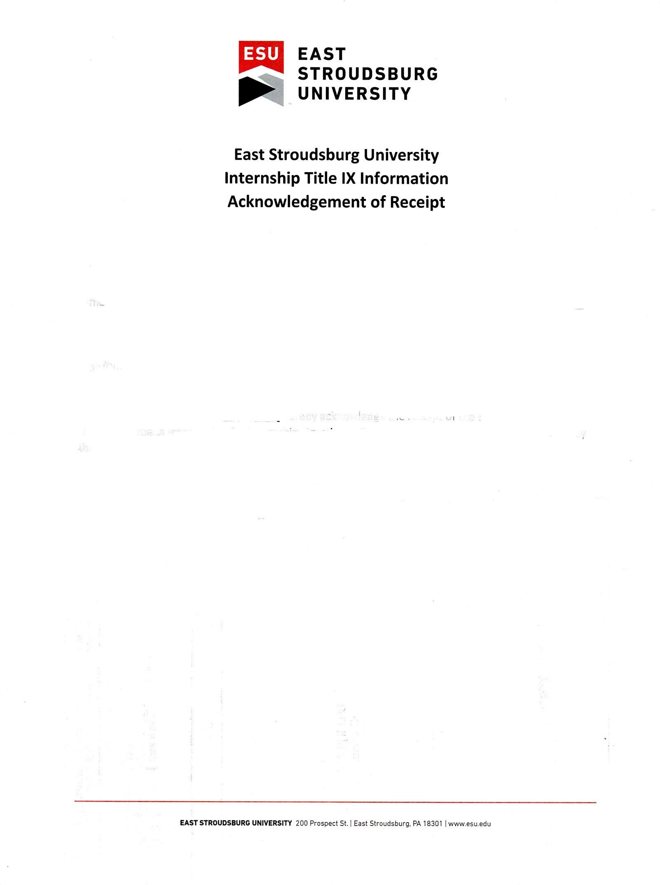

Date ____________________________________________

Name of Student:_____________________________________ Student ID #________________________

Student Email Address:________________________________

Dean/Director:________________________________________

I, ___________________________________________ hereby acknowledge the receipt of the East Stroudsburg University Title IX information for Internship, Practicum, Student Teaching, Service Learning and Study Abroad Students, and Supervisors’ documentation.

_______________________________________________

Signature of Recipient