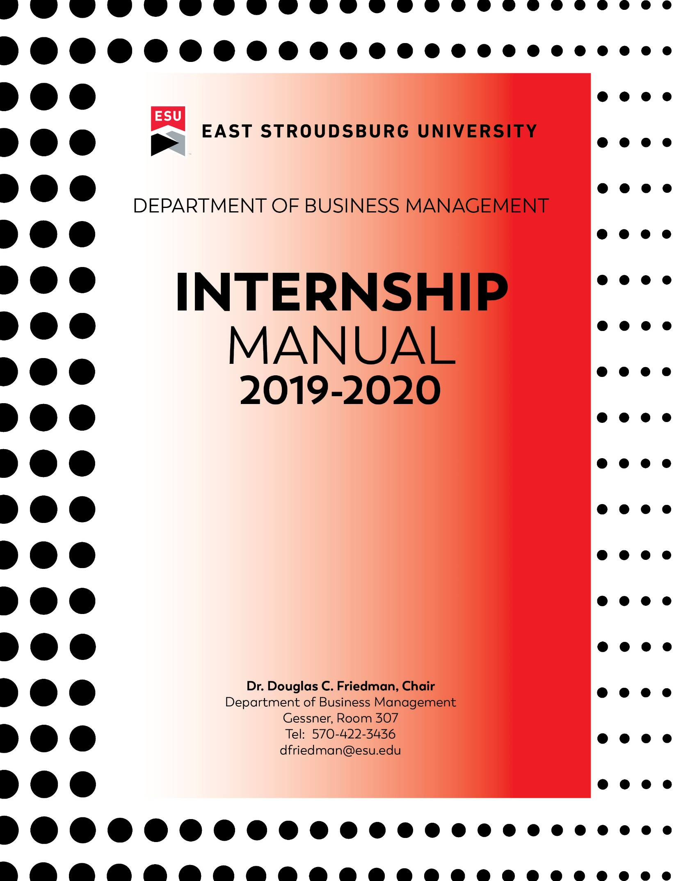

TITLE IX COMPLIANCE:
East Stroudsburg University and its faculty are committed to assuring a safe and productive educational environment for all students. In order to meet this commitment and to comply with Title IX of the Education Amendments of 1972 and guidance from the Office for Civil Rights, the University requires faculty members to report incidents of sexual violence shared by students to the University’s Title IX Coordinator. The only exceptions to the faculty member’s reporting obligation are when incidents of sexual violence are communicated by a student during a classroom discussion, in a writing assignment for a class, or as part of a University-approved research project.

Information regarding the reporting of sexual violence and the resources that are available to victims of sexual violence is set forth at: http://www.esu.edu/titleix/index.cfm

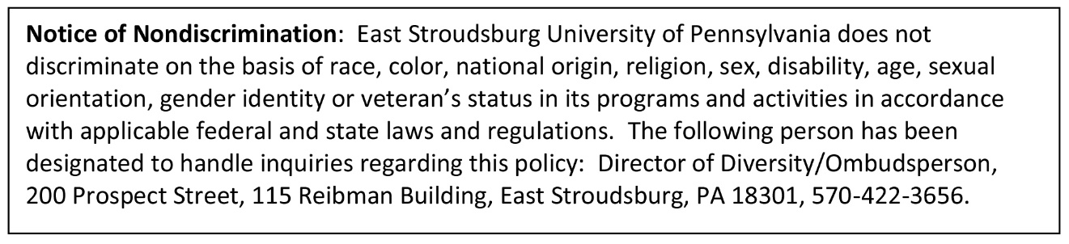

Revised August 15, 2019

BUSINESS MANAGEMENT
INTERNSHIP FAQS

QUESTIONS? Call the Department Secretary @ 570-422-3251
or email kraptakis@esu.edu
Read BM Internship Manual. Complete pages 10 and 11 of the Internship Manual with a PINK card (Request for Non-Classroom Credit) Make sure to sign it and get faculty advisor to sign.
Before you start the internship, an affiliation agreement must be signed by the company and by ESU’s Provost. The Department Secretary will obtain the necessary signatures and will send the final, signed agreement to the internship site.

To begin the process: Send an email to kraptakis@esu.edu with the following information:
- Company Name, address, city, state and zip
- Supervisor’s name, email address and telephone number

Secure Internship Site. Ask – will they allow you to do an internship for college credit? If NO, look for another site.

Speak to your advisor.
Determine how many credits and how many hours are needed for the internship.

After getting your advisor’s signature, bring pages 10 & 11 and the pink card to the Department Secretary for processing. You will also be asked to sign a TITLE IX form and receive Title IX materials. It will take about a week before you see MGT 486 Field Experiences and Internship on your ESU Portal.

Dear Student,

An internship is an excellent way to apply the knowledge gained in the classroom to the workforce. Although the Department of Business Management does not require internships for graduation, we encourage you to take advantage of earning credits for a qualifying internship.

You can earn up to twelve credits that will fulfill your free elective requirement. An internship also helps fulfill the Advanced course requirement. Please note that in order to earn credits, you must carefully follow the guidelines in the internship manual. These requirements include submitting all internship paperwork PRIOR to beginning work at the internship site. There is no retroactive internship credit. You must also provide the organization’s contact information so that they can sign an affiliation agreement. The department secretary will get the affiliation agreement processed.

Internships now require students to sign a Title IX document and receive Title IX literature.

Note: Your faculty internship advisor will tell you what type of paper will be required.

The deadline for submitting internship paperwork is the drop/add date for the semester.

Sincerely,

Dr. Douglas C. Friedman
Chair
Business Management Department

BUSINESS MANAGEMENT DEPARTMENT POLICY
FIELD EXPERIENCE AND INTERNSHIP

PURPOSE
The purpose of the field experience and internship program is to provide students with an opportunity to integrate classroom experiences with work experiences. Students are not required to participate in this program in order to graduate. This program provides students with an opportunity to:

- Apply academic principles to practical problems in a work-study environment
- Test career aspirations under controlled conditions.

RESTRICTIONS
Each individual internship shall,
- Be procured by the student (ESU does not recruit internship opportunities);
- Be determined to be a bona-fide employment internship opportunity for growth and development befitting college level credits;
- Be limited to prepared students who can demonstrate that the internship will be at least as beneficial as an equivalent amount of classroom experience and who have met the eligibility requirements set forth below;
- Be competed entirely within one (1) semester;
- Be supervised by a Professor (who will be appointed by the Department Chair) based upon the area of expertise;
- Cannot exceed twelve (12) credits.

ELIGILBILTY
To apply for an internship a student must have completed at least sixty (60) credit hours of instruction (with a GPA of at least 2.5). In addition, the student must complete the following courses before the internship can begin:
ECON 111 Principles of Macroeconomics
ECON 112 Principles of Microeconomics
MGT 200 Principles of Management
MGT 204 Principles of Marketing
MGT 211 Financial Accounting Fundamentals
MGT 212 Managerial and Cost Accounting Fundamentals
NO CREDIT will be granted if the performance of the student does not satisfy the cooperating organization supervisor. The student must perform 40 hours of field work with the cooperating agency to earn one credit. Thus,
3 credits requires 120 hours of field work;
240 hours = 6 credits
360 hours = 9 credits
480 hours = 12 credits

APPLICATION PROCEDURE AND CLARIFICATION
To apply for an internship:
- The student shall meet with his/her faculty advisor. During this preliminary meeting, the nature of the Internship will be discussed as well as the advisability of such a course of action in relation to the student’s goals.
- The student, his/her faculty advisor and the company/agency formulate the proposal for the internship. The proposal should include but not be limited to:
  - Company name, address and phone number
  - Supervisor’s name and phone number and email address
  - Length of employment (start date, end date, number of hours to be worked)
  - Description of responsibilities.
  - Letter on employer stationary confirming terms of employment and job description/duties.
- The formal proposal shall be given to the Chairperson of the Department for review by the Advisor along with a REQUEST FOR NON-CLASSROOM CREDIT card. The Chairperson reserves the right to amend the terms of the proposal, including the number of credits, work to be performed and the supervising professor.
- After the Chairperson’s review and approval by the Dean, the student will be formally enrolled by Enrollment Services and will receive a tuition bill for the number of credits taken. Students should understand that this will be treated like any other class for ESU billing purposes and if tuition is not paid the class will be dropped and no credit will be given.

SUPERVISION AND EVALUATION
Students are required to complete a Daily Log of his or her activities during the Internship program and to report once weekly (in writing) to the professor.

The student will be given an ESU Supervisor evaluation form. The employer must complete and either fax or e-mail the evaluation form weekly (or at least two times) to the supervising professor.

The instructor is required to make at least two (2) contacts with the intern’s employment supervisor. The instructor shall confer with the intern and the supervisor concerning job performance and job related problems.

The supervisor’s evaluation of the intern’s performance will be factored into the final grade. Only the instructor can assign a grade and all work and evaluations must be received by the professor by the last day of the semester in order to allow time for submission of grades.

The student is expected to behave in a responsible manner during the internship. He or she shall exhibit a professional attitude toward assigned work and conduct himself/herself as a representative of the University.

Business Management Department
East Stroudsburg University

INTERNSHIP WEEKLY REPORT GUIDELINES
A weekly report is to be given to your internship supervisor, and must include the following:

- List each of your assignments during the week and indicate the time spent on each.

- Describe new knowledge and/or skills acquired during the week.

- Explain any classroom learning that you applied to your work assignments.

- What difficulty occurred or what mistake(s) did you make on the job?
  - What did you do to correct it/them?

- In what areas could you use help in performing your job better?

- What interesting or challenging relationship did you have during the reporting period with co-worker, a client, or your work supervisor?
- Please describe.

- List any new management or labor-related information gained during the reporting period.

- List any new equipment, software, etc., used during the reporting period.

- Rate your work experience (i.e. excellent, good, average, or poor) during the reporting period in terms of social/political knowledge gained.

- List other comments and/or information, which should be included in your final report

- Supervisor to return completed checklist via e-mail to the supervising professor.

INTERNSHIP FINAL REPORT OUTLINE
Introduction
- How internship was secured.
- Dates of internship.
- Pay rate and weekly work schedule.
- Name and position of internship

Background
- Company or Firm History and date founded
- Mission and goals
- Founders, principal shareholders
- Competitors, product & service lines
- Growth statistics
- Organization Structure (Organization chart with titles and employee numbers).

Internship Objectives
- Summarize internship learning objectives.
- Which internship objectives were achieved and how.
- Which internship objectives were accomplished and why.
- What learning (e.g., office politics, interpersonal relationships, advancement characteristics and skills, etc.) you accomplished that were not included in the internship objectives.
- Which classroom learning aspects were helpful and provided knowledge/skills required on the job and why?
- What things did you wish you would have learned or known prior to starting the internship and why?

Work Description
- Describe the actual work, projects, and accomplishments completed on internship.
- Describe development of the projects and forms included in the Appendix.
- NOTE: Please do not use jargon.

Summary and Conclusions
- General reactions (good and bad) to the internship.
- Analysis of the company or firm’s management.
- Specific things you would change if you could.
- Would you like to work for this firm or one like it after graduation?
- What would you tell a fellow student about to begin an internship with the same firm/supervisor?

Appendixes
- Copies of forms and reports worked on.
- Copies of computer program-developed copies.
- Copies of systems created copies.

NOTE: Do not include any confidential information in the internship supervisor’s report.

EAST STROUDSBURG UNIVERSITY
Business Management Department - Student Internship
SUPERVISOR’S FINAL EVALUATION REPORT

Student Name:
Professor Name:
Professor Email Address:
**Student: Write or type in Professor’s email address

Please check the appropriate block for the qualities listed
 | Excellent | Good | Fair | Poor
Attendance and punctuality during the internship/practicum
Compatibility with agency staff
Rapport with agency clients
Acceptance of supervision and constructive criticism
Ability to express ideas and observations clearly
Initiative and creativity
Ability to adapt to new social backgrounds
Background knowledge pertinent to agency work
Total hours performed:

Please give a brief description of the nature, quantity, and quality of the work performed by the student intern:

Check the appropriate letter grade for the summary performance of the student intern.
A = Superior | D = Below Average
B = Above Average | E = Failure
C = Average

Signed | Date
Supervisor’s Name
Printed Name | Title
Company Name | Telephone #
If returned by fax, please FAX to 570-422-3308 and include the Professor’s Name. If returning by EMAIL, see Professor’s email address above.

INTERNSHIP APPLICATION
(Forms with missing information will not be processed)
DO NOT write in pencil. DO NOT write in pencil. DO NOT write in pencil.

A PINK “REQUEST FOR NON-CLASSROOM CREDIT” CARD MUST BE WITH THIS APPLICATION
Student’s Name: Student ID #
Major / Concentration
Total Credits Earned Cum QPA Major QPA
# of Credits for this Internship

Course Name: MGT 486 (Undergrad) MGT 586 (Grad Student)
Semester Year: Fall Spring Summer Winter

Requested Professor:
1. INTERNSHIP SITE:
Name of Organization:

Address:

City, State, Zip

2. STUDENT RESPONSIBILITY and Internship Duties (information to be learned, desired outcomes, etc.)

3. TIMELINE (dates of internship, conference dates with professor, guidelines to be followed, exit target dates, etc.)

4. CULMINATING ACTIVITIES (written report, final production, demonstration, project, etc.)

AGREEMENT STATEMENT AND SIGNATURE OF STUDENT AND PROFESSOR
I have read and agree to carry out the responsibilities and regulations as outlined in the BM Internship Manual.
Student signature | Date
Professor signature | Date

BUSINESS MANAGEMENT DEPARTMENT
INTERNSHIP SUMMARY OF CONTACT INFORMATION
(Type information and print this form)

Course Name:  MGT 486 (Undergrad) or MGT 586  Field Experiences and Internship | Internship  Semester and Year:
 | Number of Credits:

STUDENT INFORMATION:
Name: | Student ID:
Address: | Daytime Phone:
 | Cell Phone:
City, State, Zip | Home Phone:
ESU Email: | Best email contact:

INTERNSHIP SITE / EMPLOYER INFORMATION:
Organization Name:
Company Address:
City, State, Zip:
Business Telephone:
Supervisor Name and Title:
Supervisor Business Telephone:
Supervisor Email Address:
Company Website:
Internship Job Title:

Start Date: | End Date:
Work Schedule: Days/Hours

Name of Supervising Professor:

Office Phone:
Today’s Date:

PRELIMINARY LETTER FOR BUSINESS MANAGEMENT INTERNS

Student Name |  | Today’s Date
Semester |  | Advisor Name
Company or Organization

This is a preliminary letter that prospective Business Management interns will provide to their hiring manager or immediate supervisor to complete. Once completed, this letter will be given to the Secretary in the Business Management Department at ESU in Gessner 107.

The purpose of this letter is to inform the Business Management Department that the company intends to hire the above student as an intern.

The company understands that it will need to sign an affiliation agreement with East Stroudsburg University in order for the student to do his/her internship, unless an affiliation agreement has been signed within the past 5 years. The affiliation agreement will be signed by someone with signing authority and will be returned to ESU promptly. The agreement will not be final until it is signed by both the company representative and ESU’s Provost. The student and the internship site realize that the internship cannot begin without a finalized affiliation agreement in place.

This portion is to be completed by the Internship Business or Organization

Please provide a brief description of the student’s work responsibilities:

The approximate number of hours per week the student will work: __________

Printed Name of Hiring Manager or Supervisor |  | Title
Signature of Hiring Manager or Supervisor |  | Date
Business Telephone Number |  | Business Email Address

Please see the eligible types of businesses on the other side

The internship site should:
- Be operational for at least one year (will be reviewed on case-by-case basis)
- Have a Federal or State Tax ID number
- Have an internet presence (Website, Facebook page, Yelp reviews, etc.)
- Have one of the following forms of organization: S Corp, C Corp, LLC, Partnership, Sole Proprietorship or 501C 3
- Have a business telephone number and email address
- Have a valid business address that can be verified

East Stroudsburg University
Business Management Department
200 Prospect Street
East Stroudsburg, PA 18301
Department Office: 570-422-3251
FAX: 570-422-3308
All Offices located in Gessner

Business Management Contact Information
Name | Email | Telephone | Room
Dr. Douglas Friedman, Chair | dfriedman@esu.edu | 422-3436 | 307
Professor David Daniel | ddaniel3@esu.edu | 422-3485 | 309
Dr. Trib Puri | tpuri@esu.edu | 422-2712 | 312
Dr. Douglas Nay | dnay@esu.edu | 422-3768 | 313
Professor Robert Thomas | rthomas31@esu.edu | 422-3171 | 301
Dr. Daisy Wang | dwang2@esu.edu | 422-3832 | 310
Dr. Yue Xi | yxi@esu.edu | 422-3470 | 308
Dr. Weichu (Web) Xu | wxu1@esu.edu | 422-3623 | 305
Dr. Xi (Tina) Yang | xyang1@esu.edu | 422-3196 | 302
Karen Raptakis  Department Secretary | kraptakis@esu.edu | 422-3251 | 107

